Software Requirements Specification (SRS)
Project: Auto-Agent
Introduction
Auto Agent is an AI-powered orchestration system designed to bridge Large Language Models (LLMs) with real-world execution. Unlike traditional AI chatbots that generate text, Auto Agent executes actions across 800+ SaaS tools using natural language commands.
Purpose
This document defines functional and non-functional requirements of Auto Agent. It serves as a reference for developers, testers, and stakeholders.
Scope
The system provides a unified command interface that enables users to control multiple applications using natural language, execute workflows autonomously, and receive real-time feedback.
Overall Description
Auto Agent consists of Chat Module, Agent Module, Tool Router, Code Execution Module, Session Management, and Database Layer.
System Features
• Natural Language Processing using LLM
• Multi-step Workflow Planning and Execution
• Real-time Streaming Responses
• Secure Tool Routing and API Execution
• User Authentication and Role Management
Functional Requirements
FR-1: System shall accept natural language input.
FR-2: System shall analyze user intent using LLM.
FR-3: System shall route commands to appropriate tools.
FR-4: System shall log execution details.
FR-5: System shall provide role-based access control.
FR-6: System shall support sandboxed code execution.
FR-7: System shall maintain conversation history.
FR-8: System shall retry failed API calls.
FR-9: System shall ensure secure data transmission.

Non-Functional Requirements
• Performance: Response time under 2 seconds for simple queries.
• Security: Encrypted API keys and hashed passwords.
• Reliability: 99% uptime target.
• Scalability: Support for 10,000 concurrent users.
• Usability: Intuitive chat-based interface.
Database Requirements
Users Table: user_id, email, password_hash, role, created_at.
Sessions Table: session_id, user_id, context_data.
Conversations Table: conversation_id, message, role, timestamp.
Execution Logs Table: execution_id, tool_name, status, timestamp.

Use Case Diagram
The following diagram represents the interaction between users and the AutoAgent system:
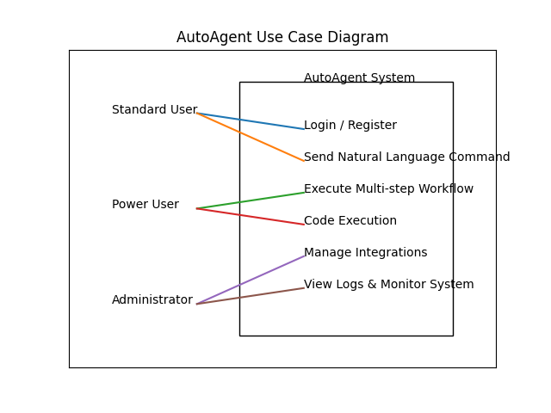

Future Enhancements
• Multi-modal input support (Image, Audio, Video).
• Mobile application development.
• Multi-agent collaboration system.
• Enterprise-grade security enhancements.

How Dynamic System Works
AutoAgent is a dynamic web-based system that generates responses and performs actions when the user sends a request. The system uses a backend server, AI engine, and database to process the data received from the web browser. The user interacts with the system through a web interface, and based on the request, the system performs appropriate operations and sends the result back to the browser.
1. The user types a command in the web browser (the client) to access the AutoAgent system. This connection also requests the interface page containing the chat form.
2. The browser connects to the FastAPI server, which contains the backend logic files that form the AutoAgent system. The server processes the request by following predefined rules and sends the web page containing the chat ssinterface back to the client.
3. The user enters a natural language instruction and submits the request through the chat interface.
4. The FastAPI server receives the submitted request and forwards it to the Agent Module. The Agent Module contains AI logic that understands the user’s intention and plans the execution steps. The system uses Google Gemini to interpret the instruction.
5. After understanding the request, the Tool Router module identifies the appropriate external tool required to complete the task. The system connects to external applications using the Composio SDK and Model Context Protocol.
The necessary API calls are executed to perform the action. 6. If required, the system interacts with the SQLite database to store session data, task history, or configuration details. When the operation is completed, the result is sent back to the backend server.
7. The backend server constructs the final response message and sends the result back to the web browser. The web browser receives the response and displays it to the user.

Web Browser (Client)

FastAPI Server (Backend)

Agent Module (Google Gemini)

Tool Router

External Tools (GitHub, Gmail)

SQLite DB

Web Browser

User Requirement Analysis

Requirement analysis is done to understand the problem that the AutoAgent system aims to solve. The main goal is to identify what the system should do, not how it will be implemented.

AutoAgent is developed to reduce tool switching and automate workflows using natural language. It connects multiple applications and performs tasks automatically based on user instructions.

There are two major activities in this phase:

1. Problem Analysis – Understanding user diAiculties like tab switching, manual workflow execution, and AI limitations.

2. Requirement Specification – Documenting all system requirements clearly in the SRS document.

Users of the System

Users are classified into two main types:

Normal User

A Normal User can:

• Login to the system

• Enter instructions in natural language

• Request actions like sending emails, managing GitHub, CRM updates, etc

. • View real-time responses

• View previous session history

The user does not need technical knowledge. The system automatically understands and executes tasks.

Administrator

Administrator manages the overall system.

Admin can:

• Manage user accounts

• Monitor system usage

• Manage tool integrations

• View execution logs

• Configure system settings

External Interface Requirements

User Interface

• Simple and responsive web interface

• Chat-based interaction system

• Real-time message updates

• Login and session management

• Dashboard for administrators

Hardware Interfaces

Server Side Requirements:

• Processor: Intel i3 or above

• RAM: Minimum 4GB

• Hard Disk: Minimum 500MB free space

• Operating System: Windows / Linux

Client Side Requirements:

• Processor: Any standard processor

• RAM: Minimum 2GB

• Internet connection

• Web browser

Software Interfaces

Server Side:

• Python

• FastAPI

• SQLite Database

• Google Gemini (LLM)

• Composio SDK

• Model Context Protocol

Client Side:

• Any Operating System

• Web Browser (Chrome, Firefox, Edge, etc.)

Communication Interfaces

• Uses HTTP/HTTPS protocol

• Server-Sent Events (SSE) for real-time communication

Functional Requirements

The AutoAgent system must provide services to Users and Administrator.

Services to Users:

• Login and Logout facility

• Natural language command input

• Automatic tool detection

• Multi-step workflow execution

• Real-time response display

• View conversation history

• Secure session handling Services to Administrator:

• Add/Delete user accounts

• Monitor system logs

• Manage connected tools

• View system performance

• Configure integrations.

Web Pages Identified

• Login Page

• Main Chat Page

• Dashboard Page

• User Profile Page

• Admin Control Panel

• History Page

System Requirements

• A computer with internet connection

• Web browser installed

• Backend server running

• API access for external tool integration

Operating System

The system supports:

• Windows

• Linux

The operating system should support Python environment and web server execution.

Web Browser

AutoAgent works in a client-server environment.

• Client sends request through browser

• Server processes the request

• Server sends response back to client

The system mainly uses HTTP protocol for communication. Supported browsers:

• Google Chrome

• Mozilla Firefox

• Microsoft Edge

Web Server
• A web server is a software application that handles requests from client browsers and delivers responses over the HTTP/HTTPS protocol.
• The web server in the AutoAgent system responds only when a request is initiated by a client browser or frontend interface.
• The responses may include HTML documents, JSON data, and additional resources such as style sheets and JavaScript files.
• The server acts as a bridge between the frontend user interface and the backend services of the system.
The commonly used web servers include:
• Apache HTTP Server, which is open-source and runs on multiple platforms.
• Microsoft Internet Information Services, which runs under the Windows operating system.

Python
• Python is a high-level, interpreted programming language used for backend development in AutoAgent.
• It is designed for readability, simplicity, and rapid application development.
• Python code is executed on the server before responses are sent to the client browser.
• Python supports multiple programming paradigms including procedural, object-oriented, and functional programming.
• It is open-source and freely available for use.

Why Python?
• Python runs on multiple platforms such as Windows, Linux, and macOS.
• It integrates easily with modern web frameworks such as FastAPI.
• Python provides strong support for AI and machine learning applications.
• It offers high performance for API-based systems and real-time data processing.
• Python simplifies backend logic for complex systems like autonomous agents.

SQLite
A well-designed database is essential for system efficiency and performance. Without proper structure and optimization, data retrieval becomes slow and inefficient.
• SQLite is a lightweight, embedded relational database management system used in AutoAgent.
• It does not require a separate database server and stores data in a single file.
• SQLite supports standard SQL queries for inserting, updating, and retrieving data.
• It is cross-platform and works on multiple operating systems.
• SQLite is suitable for storing session data, configurations, and logs.
Python + SQLite together provide a simple, reliable, and cross-platform database solution.

HTML
• HTML stands for Hyper Text Markup Language.
• It is used to structure and display content on web pages.
• HTML uses tags enclosed in angle brackets such as <html>, <head>, and <body>.
• HTML documents contain both markup tags and plain text.
• The frontend interface of AutoAgent is built using HTML5.

JavaScript
• JavaScript is a lightweight scripting language used to create dynamic and interactive web pages.
• It can function as both an object-oriented and procedural language.
• JavaScript runs on the client-side and can also be used on the server-side.
• In AutoAgent, JavaScript is used for form handling, UI updates, and real-time communication using Server-Sent Events.
• JavaScript is an interpreted language and does not require compilation.

Cascading Style Sheets (CSS)
• CSS stands for Cascading Style Sheets.
• It is used to control the presentation and layout of HTML documents.
• CSS defines how HTML elements are displayed, including colors, fonts, and spacing.
• External style sheets are stored in .css files.
• CSS helps create responsive, fast-loading, and visually consistent web pages for AutoAgent.

